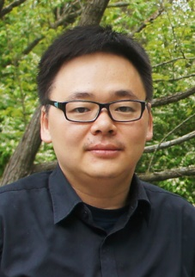 | Dr. Gengyuan Liu, Associate Professor  School of Environment, Beijing Normal University  - Research interests cover Urban Ecological Planning and Waste Management, Emergy Analysis, Food-Energy-Water Nexus  - Four-years’ faithful service as Secretary-in-Chief for China Chapter of International Society for Advanced Emergy Research  - Five-years’ service as Advanced Editorial Assistant for Journal of Environmental Accounting and Management  - Secretary-in-Chief for World Emergy Summit 2016 on Environmental Accounting and Management, Beijing, 2016  - Organizer of the International Emergy Course on Environmental Accounting and Management in BNU in 2013, 2014, 2015, 2016.  - Teacher of Emergy course (Energy Economics, in both Chinese and English) from 2013 to 2016.

